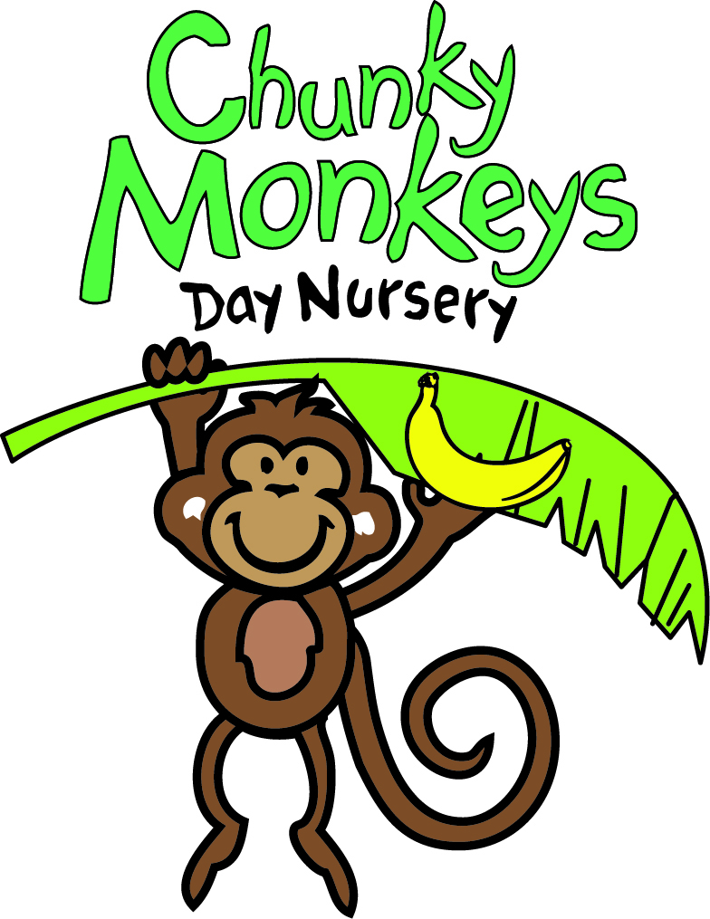

**Child Allergy Management Plan**

Here at Chunky Monkeys we have policies and procedures in place to ensure a supportive and as risk free environment as reasonably possible for all the children in our care.

**Child’s Name:** ____________________________

Our Allergy Management Plan acts as a reference for all staff members and is a means of reassuring our parents that everyone involved in the care of their child is aware of their allergies and the danger of exposure to allergens.

1). Clearly describe what your child is allergic to.

2). Outline a description of what symptoms your child shows/may show when having an allergic reaction.

3). Description of regular treatment required during the day and how often the treatment should be given e.g. eye drops during hay fever season twice a day. Please ensure your child’s medication is clearly labeled.

4). To prevent any staff panic and uncertainty in the event of an emergency, please list simple step-by-step instructions explaining how the reaction should be managed.

5). In order to ensure your child’s Allergy Management Plan is as accurate as possible, please keep staff and management updated about any changes to your child’s allergy.

6). Please provide your written consent for staff to take responsibility for administering any medication prescribed to your child for treating the allergy.

Ensure the medication is readily accessible, clearly labeled with the child’s name and instructions for use and that all staff are aware of where the medication is stored.

Signed by Parent/Carer: ………………………………………………………….

Date:………………………..